Cole's Tours & Travel
"Great Destinations Start ... and End Here" SOLD OUT

Niagara Falls May 18-23, 2026

Date:

Come travel as we visit the majestic Niagara Falls! We will spend 1 night en route in Washington, PA; with 3 nights at the Hilton Falls view hotel, on the Canadian side with floor to ceiling views of the Falls! Returning home, we will spend 1 night back in Washington, PA. All hotels have casinos, restaurants, and shopping within walking distance or shuttle service. A city Tour of the Falls is included. Plus you will have time on your own to enjoy the Falls. Don’t miss out. *A Passport is required for this trip****
Depart from:
Columbia Place Mall. 7201 Two Notch Rd.
…………………..……...Book now this will sell out!!..................................
- per room = $1,195.00 per person
- per room = $770.00 per person
- per room = $655.00 per person
- per room = $585.00 per person
Cost includes all Tours, Hotels and Bus

Cole’s Tours & Travel
4611 Hard Scrabble Rd Ste 313
Columbia, SC 29229
Highlights:
- Niagara Falls City Tour
- Fun and Fellowship
- Shopping and Casinos
O r g a n i z a t i o n
- And more

Deposit: (Non-Refundable) $50.00 pp June 1, 2025 2nd payment: $200.00 pp October 1, 2025
3rd payment: $200.00 pp February 1, 2026
***Final Payment: Balance April 1, 2026
**Cash app available: $chrisctt .... Please specify “Niagara Falls”
(Signup Sheets MUST be turned in with your Deposit)
***Make Checks Payable to: Cole’s Tours & Travel


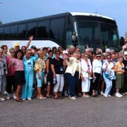

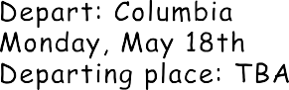



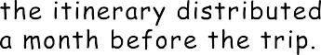






Chris's email: seecole4travel@yahoo.com ***Please make payments on time
Rosalind’s email: seeroz4travel@aol.com
******A Passport is required for this trip******

Room SIGN-UP SHEET
Niagara Falls May 18-22, 2026

Room Type: (Circle one) *King 2 Double Beds (*Note: King room not guaranteed/is based on hotel availability)

Guest 1: Address: City: State: Zip: Telephone #: (home): (cell): Email address:
Emergency contact:
Name: Relationship: Telephone #: (home): (Cell):
Notes:

********************* ROOMMATE ***********************

Guest 2: Address: City: State: Zip: Telephone #: (home): (cell): Email address:
Emergency contact:
Name: Relationship: Telephone #: (home): (Cell):
Notes:

Confidential Notice:
All information provided above will remain on record with Cole’s Tours and will not be disclosed to any other individuals.

Thank you for traveling with us.

