Cole's Tours & Travel
Cruising to: San Juan
Celebration Key &
St Thomas, Virgin Islands

Dec 7-14, 2025

SOLD OUT

Time:

Get ready to set sail on the all-new Carnival Celebration as we sail to the beautiful Eastern Caribbean for 7 fun-filled days, visiting 3 Islands! There’s something for the whole family to enjoy on this amazing ship! Come sail with your Family & Friends!! Rates include pre-paid gratuities and Bus!
 | 2 per Room | *3 per Room | *4 per Room
Interior: | $1095.00 pp | $945.00 pp | $706.00 pp
Balcony | $1405.00 pp | $1155.00 pp | $1025.00 pp

Contact:
Chris: 803-530-4025

Colestours.com
"Great Destinations Start and End
Here"

*3 and 4 per room will need $250.00 per person deposit
to book !!
Room location and dining preferences are not guaranteed until a total of payments of $250.00 per person in each room are received.
Itinerary
- Sun: Miami FL Depart 4:00 PM
- Mon : Fun Day at Sea
- Tue: Fun Day at Sea
- Wed: St. Thomas, USVI 9:00 AM - 6:00 PM
- Thur: San Juan 7:00 AM - 3:00 PM
- Fri: Fun Day At Sea
- Sat: Celebration Key
- Sun: Miami, FL 8:00 AM
O r g a n i z a t i o n







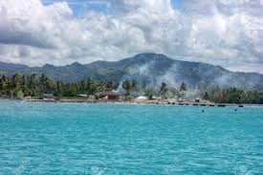

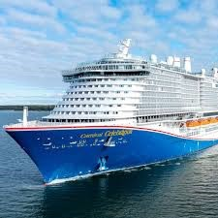

Payment Plan per person: (Final balance varies per room)
Please note, Cabins are not assigned until $250.00 paid. Payments can be made before, but not later than the listed date

*1st Payment (Deposit) $25.00 or $250.00 (3 or 4 in room): by OCT 15, 2024: To guarantee group rate & cabin
*2nd Payment: $250.00: by February 1, 2025
*Final Payment/Balance: by September 1, 2025 (*No exceptions, no extensions
Cabin sign-up sheet must be included with the deposit.
Chris Cole 803-530-4025
Cash App Chris Cole 803 -530-4025 to $chrisctt
*** Make Money Orders or Checks payable to:
Cole’s Tours & Travel
4611 Hard Scrabble Rd, Suite 313 Columbia, SC 29229
**All major credit cards are accepted** Call 803 -530-4025 to make credit card payments

)

Cole’s Tours & Travel
4611 Hard Scrabble Road, Suite 313, Columbia, SC 29229 Friends and Family Cruise– Dec 7-14, 2025 Room SIGN-UP SHEET
Room Type: (Circle one): Inside Balcony
Guest 1 (Legal Name)___________________________________________________________
Address: City: State: Zip: Date of Birth:
Telephone #: (home): (cell):
Email address: Emergency contact:
Name: Relationship:
Telephone #: (home): (Cell): Notes:

*********************** ROOMMATE***********************
Guest 2 (Legal Name): Address: City: State: Zip: Date of Birth:
Telephone #: (home): (cell): Email address:
Emergency contact:
Name: Relationship: Telephone #: (home): (Cell):
Notes:

Confidential Notice:
All information provided above will remain on record with Cole’s Tours & Travel and will not be disclosed to any other individuals.

Thank you for traveling with us.
“Great Destinations Start… And End Here”

